Contract for ILARA Health Admin Panel and Messaging Application

Between

Tekrowe Digital Private Limited (Developer)
Contact: Shoaib Akmal
CEO Tekrowe Digital Private Limited shoaib.akmal@tekrowe.com
+92 3453333243

And



ILARA HEATLTH LIMITED
Nicolos Alonso Head of Growth
Nicolas.alonso@ilarahealth.com
+254742267066
24a St Michaels Road, Nairobi, Kenya

This agreement “Contract” is made at Islamabad on this March 21, 2021 “Effective Date”, by and between.
TEKROWE DIGITAL (PRIVATE) LIMITED, a company incorporated under the laws of Pakistan having its registered office at House no. 114, Street No. 37 Sector F-10/1, Islamabad, hereinafter referred to as the “Developer”,
AND
ILARA HEALTH LIMITED, registered in Nairobi, Kenya hereinafter referred to as the “Client”
Developer and Client shall wherever the context, so permits be individually referred to as the “Party” and collectively as the “Parties”.
Client wants to develop a patient monitoring admin panel that will be a central point to configure, administer and control the ILARA Health mobile application, its users i.e. patients, agent/staff/practitioner, and clinicians.
In addition to admin panel, client wants to build messaging workflows on patients mobile app for effective communication between patients and practitioners/agents/clinicians.
Scope of Work
1.0 High Level Scope of work
- Tekrowe will engage its engineering team to build the patient monitoring admin panel and messaging app according to following shared scope and wireframes ONLY:
https://confluence.external-share.com/content/7f58ce67-7ea5-43e6-8f03-70859c079187 https://xd.adobe.com/view/7d2b8b95-5f1f-4600-b5f8-1f800a1c5a58-2878/ https://confluence.external-share.com/content/e7114690-3f93-4136-a81f-5548044a9b54
- This Scope of work covers development of Web based Admin Panel and Web & Mobile (Android) interfaces of messaging app.
- ILARA Health will be responsible for providing wireframes for both the apps.
- ILARA Health will be responsible for sharing its backend APIs for Authentication, search, and other functions with the Tekrowe.
- ILARA Health will be responsible to share the end points for the backend solution
- Messaging App development will only be started after the completion of all limitations in the backend by ILARA Health’s development team.
- Tekrowe will be responsible to implement the frontend and integration with the backend using the shared end points.

- Tekrowe will do the end-to-end System Integration Testing for all the PBIs during a specific sprint and before pushing anything from Stage to Production. ILARA health team will share the preferred test cases that will must verify.
- Source code will be hosted on ILARA Health’s code repository (BitBucket, GitHub etc.). ILARA Health will be responsible for managing access for Tekrowe’s Engineers.
- Tekrowe will provide support for managing application releases using ILARA Health’s Google’s Play Store account. ILARA Health will be responsible for providing access to Google Play Store.
- Product Development Team will follow the Agile Development methodology or similar approach preferred by the client.
- Client will provide testing and acceptance criteria based on which testing and UAT will be completed.
- 30 calendar days post deployment support by Tekrowe project team

High Level Team Requirement
Based on Client requirements Tekrowe will provide MERN Stack engineers and REACT Native developers on fixed cost basis that will work closely with the Client or any assigned Technical Lead. Tekrowe will assign an Engineering team consisting of Web Developers, React Native Engineers, QA Engineers, and a Project Manager for the agreed upon duration to complete the MVP of the product

Price and Payment terms
  - All prices are stated in USD
  - The prices and terms of pricing as mentioned in section 5.0 shall be exclusive of any sales tax and all the payments shall be subject to deduction of withholding taxes as per laws of Pakistan is applicable.
  - Any applicable tax shall be responsibility of the Client.
  - Payments will be due based on Project Milestones as identified in the project plan.

4.0 Termination
This Contract and its terms shall be for the duration of the product development Upon completion of this Contract, a new contract may be drafted for any other development needs. by the mutual consent of the Parties.

Notwithstanding any other provision of this Contract, the Developer and Client have the right to terminate this Contract without assigning any reason whatsoever, before the second payment milestone is reached. In such a case, any payments made will not be refunded.

Termination with cause. Either Party shall be entitled to immediately terminate this Contract if;
- The other Party commits a breach of this Contract (other than a breach capable of remedy); or
- The other Party commits any breach of any of the provisions of this Contract which is a breach capable of remedy and fails to remedy the same within 10 days after receipt of a written notice giving full particulars of the breach and requiring it to be remedied.
- Termination of this Contract shall be without prejudice to the rights and obligations which accrued prior to the termination or which by their terms are intended to operate/continue upon or after termination.

- Post-Termination Rights : Fees Owed to the Developer. In the event of termination of this Agreement by either party for any reason, Client shall pay Developer for all work and expenses accrued prior to the effective date of such termination.

- Intellectual Property Rights. In the event of termination of this Agreement by either party for any reason, Developer shall fully transfer all IP ownership for all paid work accrued prior to the effective date of such termination.

- Any unresolved disputes remaining after termination of this Agreement shall, nnotwithstanding such termination, be resolved in accordance with the provisions hereof.

- Post termination, the Client and Developer will coordinate to develop a transfer plan of all development activities, timeframes, resources, and processes to either another Technology partner defined by the Client or the Client’s internal development team.

5.0 Project Pricing

Mobile Application Development Cost for the project will be as follows

Time Estimates (Weeks) | 8 weeks
Total Cost | US$ 1000
Discount | 33%
Final Project Cost | US$ 600

Payment Milestone:
- Wireframe development of Admin Panel → US$ 1,00
- Completion of Admin Panel → US$ 3,00
- Completion of Messaging App → US$ 2,00

Payment Method
All Payments will be in USD and transferred via Wire / Bank Transfer to Tekrowe Digital Private Limited Account in Pakistan. Account information will be provided to the Client. Payments will be made according to payment milestones as laid out in the project plan.

Intellectual Property
The rights to all Intellectual Property developed as a part of this engagement resides solely with the Client. Source code, design and any relevant documentation will be handed over to the client after completion of the engagement and payments.

Terms and Condition
  - All equipment and office support will be provided by Tekrowe. This includes internet, laptop, tools, seats, conference rooms, kitchen facilities etc . Team will be sitting in Tekrowe Office location.

  - Physical medical devices needed during the project will be provided by Ilara Health to Tekrowe team.
  - Wireframes and SDK’s will be provided by Ilara health
  - The development, testing and production environments on the AWS/Azure/Google Cloud will be client’s responsibility
  - Any update in provided SDK and APIs will be communicated to Tekrowe team immediately.
  - Tekrowe will not commit to make any changes, upgrades in existing SDKs and APIs
  - Any change in the scope mentioned above in section-1 will be addressed through a standard change control process
  - Project will be considered complete after successful completion of User Acceptance Testing.
  - Tekrowe Digital will provide 45 days Post acceptance Warranty. Any bugs / issues related to the MVP implementation of features will be addressed by Tekrowe Digital without any additional charges.
  - Tekrowe Digital will do the testing based on most commonly available Android Devices and Software versions. Any Testing on devices / Software version specific to local Client market and environment will be responsibility of the client.

Confidentiality and Non-Disclosure Agreement
A Prior NDA has already been signed between the Developer and Client. All terms and conditions agreed in the prior signed NDA will continue through the duration of the contract,
- Each Party acknowledges that in the course of the performance of this Contract it may obtain Confidential Information of the other Party. The Receiving Party shall, at all times, both during the term of this Contract and thereafter for a period of two keep in confidence and trust all of the Disclosing Party’s Confidential Information received by it. The Receiving Party shall not use the Confidential Information of the Disclosing Party other than as necessary to fulfill the Receiving Party’s obligations or to exercise the Receiving Party’s rights under the terms of this Contract. The Receiving Party shall take reasonable steps to prevent unauthorized disclosure or use of the Disclosing Party’s Confidential Information and to prevent it from falling into the public domain or into the possession of unauthorized persons, but in no event shall the Receiving Party use less care than it would in connection with its own Confidential Information of like kind. The Receiving Party shall not disclose Confidential Information of the Disclosing Party to any person or entity other than its officers, employees and consultants who need access to such Confidential Information in order to effect the intent of this Contract and who have

entered into confidentiality agreements which protect the Confidential Information of the Disclosing Party sufficiently to enable the Receiving Party to comply with this Section.
- Permitted Disclosures. Nothing in this Contract shall prevent the Receiving Party from disclosing Confidential Information to the extent that Receiving Party is legally compelled to do so by any governmental investigative or judicial agency pursuant to proceedings over which such agency has jurisdiction; provided always, that prior to any such disclosure, the Receiving Party shall (i) assert the confidential nature of the Confidential Information to the agency; (ii) to the extent permitted by applicable law, immediately notify the Disclosing Party in writing of the agency’s order or request to disclose; and (iii) cooperate fully with the Disclosing Party in protecting against any such disclosure and/or obtaining a protective order narrowing the scope of the compelled disclosure and protecting its confidentiality. Either Party may provide a copy of this Contract to the following persons and/or entities who are under obligations of confidentiality substantially similar to those set forth in this Contract: potential acquirers or investors and to their employees, agents, attorneys, investment bankers, financial advisors and auditors in connection with the due diligence review of such Party. Either Party also may provide a copy of this Contract to: (i) the Party’s public accounting firm in connection with the quarterly and annual financial or tax audits, and (ii) to the Party’s outside legal advisors in connection with obtaining legal advice relating to this Contract, the relationship established by this Contract or any related matters, provided that they are also under obligations of confidentiality substantially similar to those set forth in this Contract.

10.0 Communication
All communication concerning the Contract shall be directed to:

Commercial

Developer

Name | Muhammad Shoaib Akmal
Telephone | +92 345 3333243
E-mail | shoaib.akmal@tekrowe.com
Technical
Name | Asim Ajmal
Telephone | +92 3008500329
E-mail | asim.ajmal@tekrowe.com

Commercial

The Client

Name | Nicolas Alonso
Telephone | +254742267066
E-mail | Nicolas.alonso@ilarahealth.com

Technical
Name | Alloys Mila
Telephone
E-mail | Alloys.mila@ilarahealth.com

IN WITNESS WHEREOF the Parties have hereunder set their hands on the day and year first above written.

FOR AND ON BEHALF OF TEKROWE DIGITAL (PRIVATE) LIMITED
FOR AND ON BEHALF OF
ILARA Health Limited


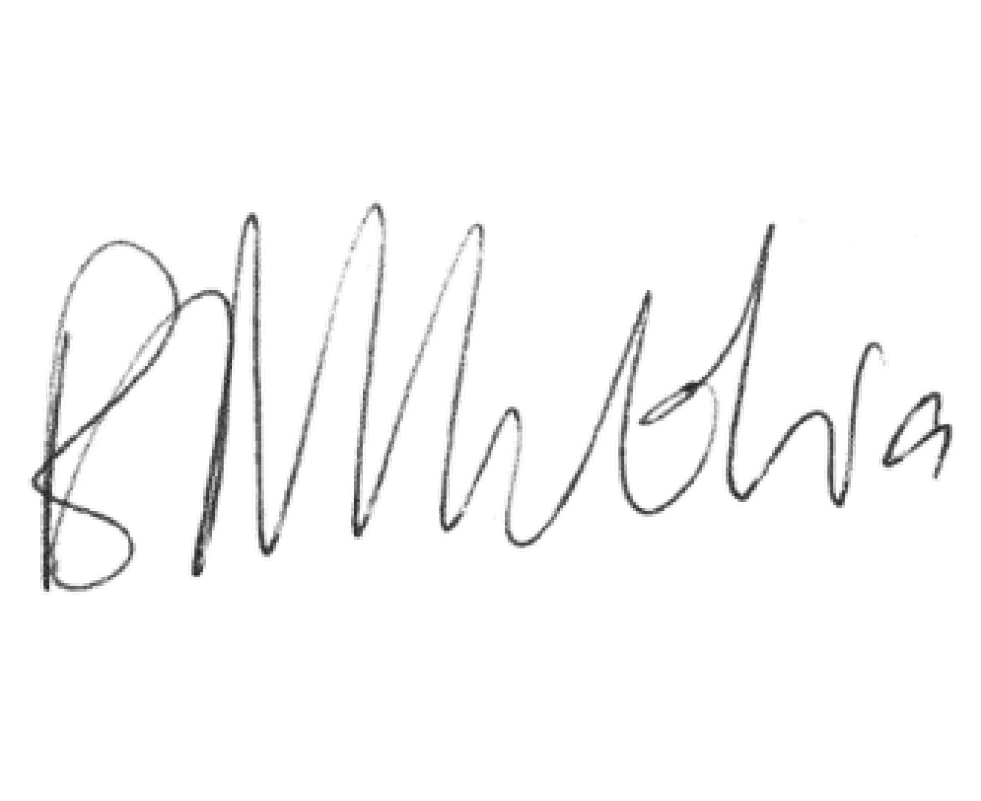
Signature: Signature:

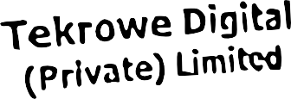
Eric Mbuthia Kanyi For Ilara Health.
March 25, 2022.

Name: Shoaib Akmal
CEO Tekrowe Digital Private Limited
Name: Nicolos Alonso
Head of Growth, ILARA Health Limited.

